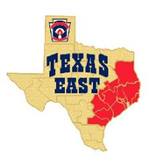

Little League International Tournament
Texas East State Qualifiers Packet
Friday July 10th – Wednesday July 15th 2026

Pearland Little League complex at the Dads Club
6614 Fite Road
Pearland, TX 77584

Dear Manager,
Congratulations to you and your team on qualifying for the 2026 LL Texas East State Tournament.
We are excited to host the best little league teams from each section of Texas East and watch you all compete for the title of Texas East State Champion.
We are preparing a fantastic experience for the players, coaches, families and fans. As you prepare to visit the facility in Pearland for the tournament please review the information enclosed within this packet. In order to help us we would appreciate your timely attention to the pre-order information for BBQ plates, Parking, and T-shirts.
Also, please send a picture of your team to: information@pearlandlittleleague.com, we plan to utilize it in promotion for the tournament.
Items to bring with you:
- 1 dozen tournament baseballs
- Team binder with all affidavits
- Medical release form for every player
- Diamond Leader Training certificates
- Abuse awareness training certificates
- Sectional and district banners

If you have any questions please contact:
Manny Carillo – D15 Administrator – 713-371-8967
Troy Johnson – President Pearland Little League – 316-393-4498

2026 Texas East State Tournament Schedule
Texas East State website: tshq.bluesombrero.com/txeastll/
Links to all Texas East State Baseball brackets will be posted on the Texas East State website. The scores of all games will be updated daily for all divisions of play.

Friday July 10th – Opening Ceremonies
5:00-6:00pm – Team check-in – Affidavit and book check – Dads Club Hall building
5:30-7:00pm – BBQ Dinner – Meet and Greet
7:00pm – Opening ceremony – Major Field
Announce All teams – parade onto the field
Announce Umpires for each division
National Anthem, recite the pledge
Announce Sponsors
First Pitch – Caden Ferraro
7:30pm – Skills Competitions – All teams
8:30pm – Close out opening ceremonies

Saturday July 11th – Game day
10:00am – Team check in – Affidavit and book check – Dads Club Hall building
11:00am – Manager/Coaches/Umpires meeting – Dads Club Hall building
MANDATORY: All managers and one coach are required to be present. All policies, schedules, ground rules, tournament format, practice schedules, and other topics will be discussed.
5:00pm – Game 1 for all divisions
8:00pm – Game 2 for all divisions

Sunday July 12th – Game day
5:00pm – Game 3 for all divisions
8:00pm – Game 4 for all divisions

Monday July 13th – Game day
7:00pm – Game 5 all divisions

Tuesday July 14th - Game day
6:00pm – Game 6 all divisions
If necessary – Game 7 will start 30 minutes after game 6
Opening Ceremonies
5:30-7:00pm – BBQ Dinner – Meet and Greet - We are kicking off this state tournament with a meet and greet BBQ dinner.
All players and coaches will be provided with a ticket to get a free plate.
Family and friends may pre-purchase tickets at the link below. Additional tickets may be purchased on-site.
https://pearlandlittleleaguestore.square.site/
7:00pm – Opening ceremony – Major Field
All teams will assemble on the Minor Field outfield at 6:45pm
We will announce all teams – parade onto the field carrying your sectional banner
National Anthem, recite the pledge
Announce Tournament Sponsors
First Pitch by Caden Ferraro (Texas Tech)
7:30pm – Skills Competitions – All teams
  - Major Field - Hitting Competition - 2 players from each team, get 10 total pitches total (thrown by your own coach), must hit the first three into left field, second three into CF, and third 3 into RF. Last pitch is call your shot
  - Minor Field - Around the Horn - All players start on their targets, Clock starts when the pitcher throws the ball, every player must touch the ball and return it to the Pitcher to stop the clock
  - CP Field - Bunting Competition - 2 players from each team, Targets to be placed on the field. 10 pitches from a machine
  - TB Field - Base running Competition – 6 players from each team will start in the LH batters box and run a HR. The 4 fastest times will be combined to set your teams time. Lowest cumulative time wins
8:30pm – Close out opening ceremonies – Prize for the winning team of each age division
Facility Rules
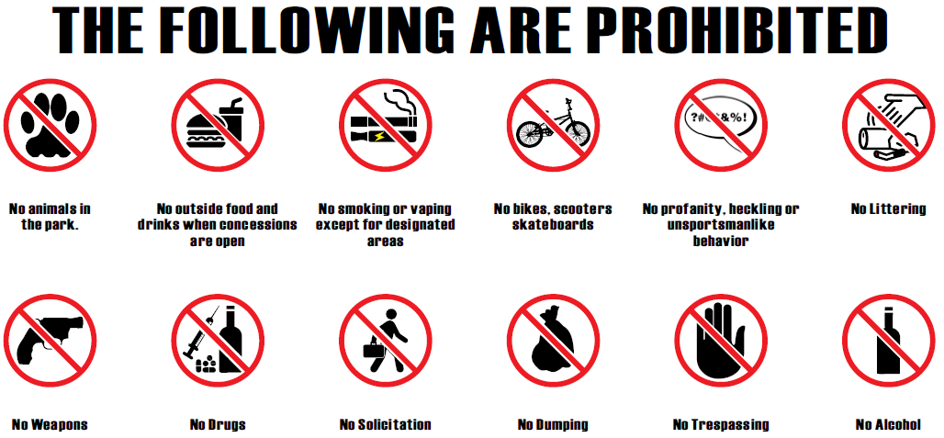
Live Streaming of Games
Pearland Little League has a video streaming service that can be accessed by all fans. The streams can be accessed by going to www.pearlandlittleleague.com/FanCams or www.varsityhype.com/
Recording devices, including but not limited to cell phones, video cameras, etc., are not permitted to be attached to a field’s backstop or adjacent/surrounding fencing and/or dugouts.
Please refer to LL Streaming Guidelines page on this website for more information or visit https://www.littleleague.org/help-center/internet-webcast-and-streaming-faqs/

Spectator Behavior
The Tournament staff would like to remind all spectators of our Zero Tolerance Policy, which states:
Any person, or persons, who publicly criticize the umpires, tournament officials, opposing players or coaches will be asked to immediately leave the complex and will be barred from the complex for the remainder of the Tournament.
Tournament officials will ask that all players be placed in their respective dugout and play stopped until the offender, or offenders, leave the complex. Foul language or poor sportsmanship by any spectator will not be tolerated and wiII result in the offender, or offenders, being barred from the complex for the remainder of the Tournament.
Noisemakers (such as bells, sirens, whistles, horns, jugs with rocks in them, or any other type) are strictly prohibited. Any action taken for the obvious intent of distracting the opposing players wiII absolutely not be permitted. The umpires and tournament officials reserve the right to rule on any noise or action which they feel is an attempt to distract the opposing players.

Parking Fee
A Parking Fee of $10/day will be charged for all vehicles. This fee helps offset the costs associated with putting on this event.
If you would like to prepurchase your parking for the entire tournament for $35 you may do so at the link here:
https://pearlandlittleleaguestore.square.site/
You may pickup your parking pass at opening ceremonies or they will be available at the parking stations on game days.
Merchandise for sale
We are pleased to offer T-shirts to commemorate the state tournament. All teams will be listed on the shirt
We are offering a preorder link because onsite inventory will be limited – Using this link will guarantee you a shirt and it will be available for pickup at opening ceremonies.
Front back

Teams participating in each division to be listed on the back
https://pearlandlittleleaguestore.square.site/

Facility Map
Pearland Area Dads Club
6614 Fite Road
Pearland, TX 77584

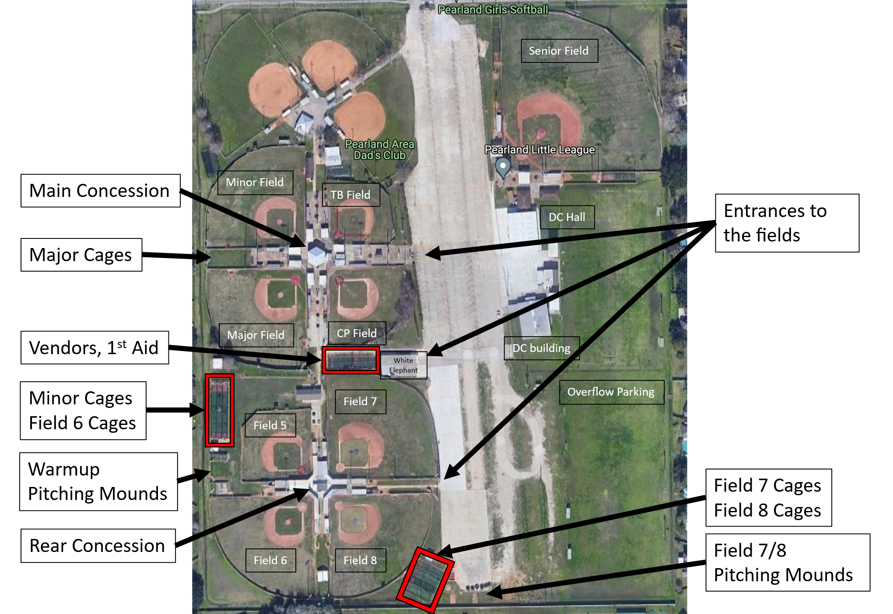

Pearland Area Hotels and Restaurants
https://visitpearland.com/events/2026texaseaststatetournament/
Discounted blocks available at:
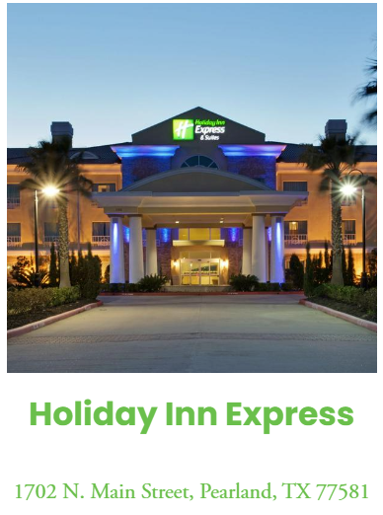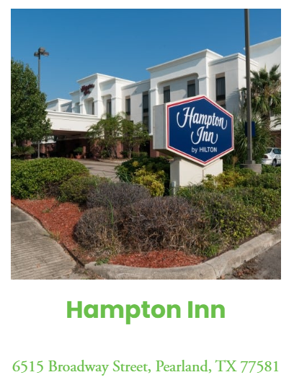
Additional Hotel Options available at
https://visitpearland.com/stay/pearland-hotels/
Field Information
Practices
If your team desires to practice on one of our fields outside of gameplay/warmups please check with the tournament host for availability.

Games
Little League baseball (10-12yr old) – All games to be played on the Major field
9-11 Baseball – All games to be played on the Minor field
8-10 Baseball - All games to be played on Field 6

Pregame Batting Cages
Every field has assigned batting cages. They are labeled by the field and the Home/Away status. Every team will get two cages prior to their games. The cages will be assigned as follows:
- Major Field covered cages Home/Away – LLB bracket – Top team listed in the matchup
- Minor Field Home/Away – LLB bracket – Bottom team listed in the matchup
- Field 5 and Field 6 Home – 9-11 bracket – Top team listed in the matchup
- Field 5 and Field 6 Away – 9-11 bracket – Bottom team listed in the matchup
- Field 7 cages Home/Away – 8-10 bracket – Top team listed in the matchup
- Field 8 cages Home/Away – 8-10 bracket – Bottom team listed in the matchup

Pre game field warmups
See the Tournament play Game timings for exact times for the game fields for on-field warmups.

The following fields not being used for game play may be used for warmups prior to game time. We will not be assigning times for each team, the expectation is the two teams can coordinate to make it work for both sides. If the tournament host has to step in we will, any decision made by the host will be final.
Coach pitch field – 8-10yr old division – *This is a smaller field, so outfield warmup may be limited.
Field 8 – 9-11yr old division
Field 7 – 10-12yr old division
Tournament Play - Game Timings
First Round Games and Championship game
60min ahead of game time – Meet with tournament official and flip for Home/Away and turn in lineup cards for the official scorekeeper
Home team will occupy the 3rd base dugout
Visiting team will occupy the 1st base dugout
30 min prior – Announce Visitors to take the field for infield/outfield warmup– 6 minutes
24 min prior – Announce Home to take infield/outfield warmup – 6mins
18min prior – Announce All teams return to the dugouts
15min prior – Introduce Players and Managers from both teams - Line up at the foul line as your name is called
10min prior – Play the National Anthem
After the anthem – Players return to the dugout, Managers meet with the Umpires at home plate
Upon conclusion of plate meeting - Home team takes the field for player and pitcher warm-ups

All other games
60min ahead of game time – Meet with tournament official and flip for Home/Away and turn in lineup cards for the official scorekeeper
Home team will occupy the 3rd base dugout
Visiting team will occupy the 1st base dugout
24 min prior – Announce Visitors to take the field for infield/outfield warmup– 6 minutes
18 min prior – Announce Home to take infield/outfield warmup – 6mins
12min prior – Announce All teams return to the dugouts
10min prior – Both teams lineup on respective foul lines - Play the National Anthem
After the anthem – Players return to the dugout, Managers meet with the Umpires at home plate
Upon conclusion of plate meeting - Home team takes the field for player and pitcher warm-ups

